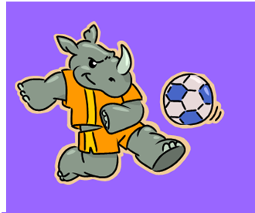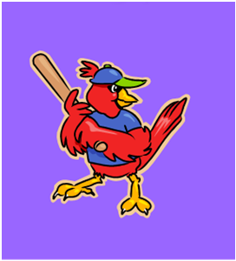

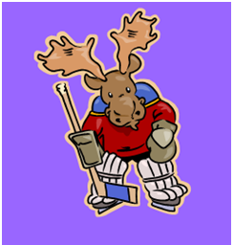

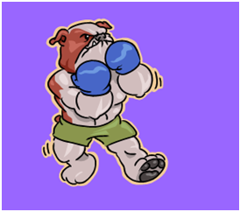

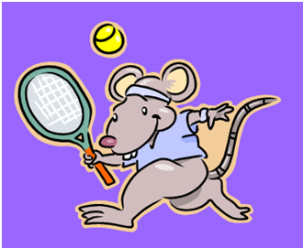





**A sound mind in a sound body.**

**Tennis**

**Basketball**

**Football**

**Golf**

**Skiing**

**Skating**

**Tobogganing**

**Swimming**

**Running**

**Hockey**

**Diving**

**Chess**

**Lapta**

**Jumping**

**Badminton**

**Volleyball**

**You are our future!**

**A sound mind in a sound body.**

**Tennis**

**Basketball**

**Football**

**Golf**

**Skiing**

**Skating**

**Tobogganing**

**Swimming**

**Running**

**Hockey**

**Diving**

**Chess**

**Lapta**

**Jumping**

**Badminton**

**Volleyball**

**You are our future!**

**A sound mind in a sound body.**

**Tennis**

**Basketball**

**Football**

**Golf**

**Skiing**

**Skating**

**Tobogganing**

**Swimming**

**Running**

**Hockey**

**Diving**

**Chess**

**Lapta**

**Jumping**

**Badminton**

**Volleyball**

**You are our future!**